**WEEK II:**

* KNN for article retrieval, i.e. measure distances based on similarity and find the one with least distance.
* Document representation and way to find distances are critical for knn.
* **Documents representation:**
* Bag of words model.
* TFIDF representation
* **Distance representation:**
* **Euclidean**
* **Scaled Euclidean;** Some features are more important than others or if they vary less their coeff are small. So, we weigh them more. We can also scale the features in the second case:

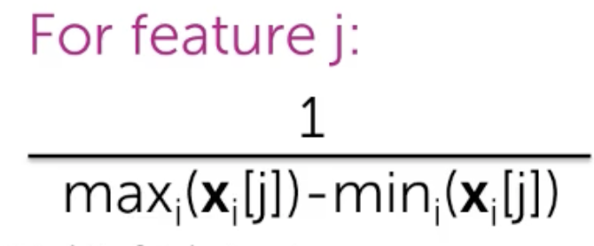

* Scaled Euclidean distance can also be 0 and 1. This feature scaling is important and hard because sometimes it is important, sometimes not required..
* Matrix representation of Euclidean distance. For scaled, we just add another matrix i.e. a diagonal matrix.
* Cosine similarity:
* 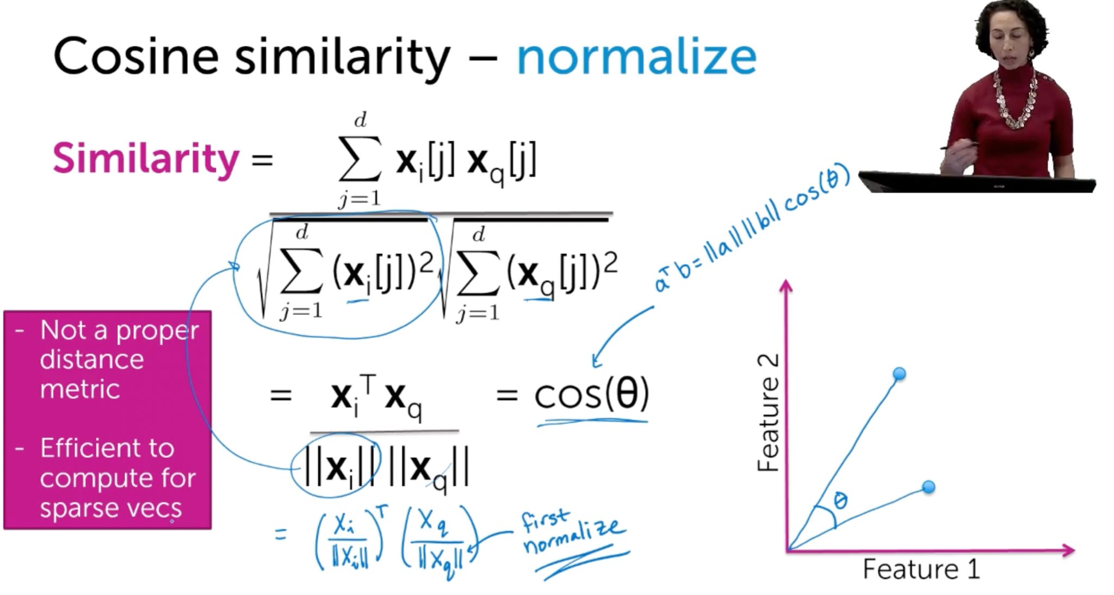efficient for sparse bcoz only non 0 elements are considered.
* Sparse vector: Vector with mainly 0 as an element.
* 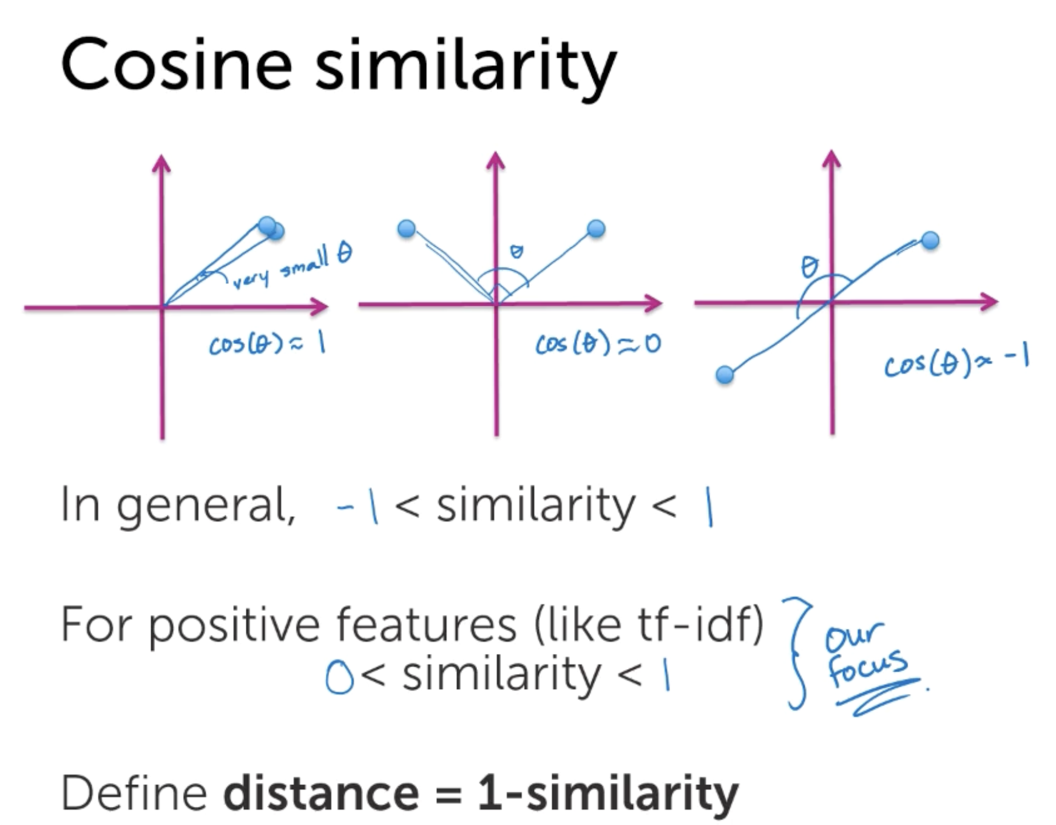
* Should normalisation be done or not? Cosine similarity does not depend on the length but only on the content which sometimes is not useful, say a book is similar to a tweet.
* Different distances can be used in a same problem

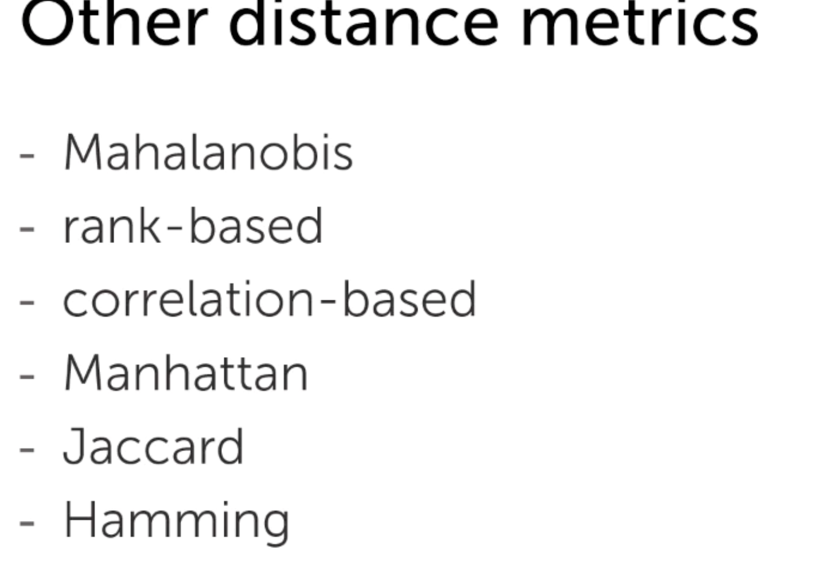 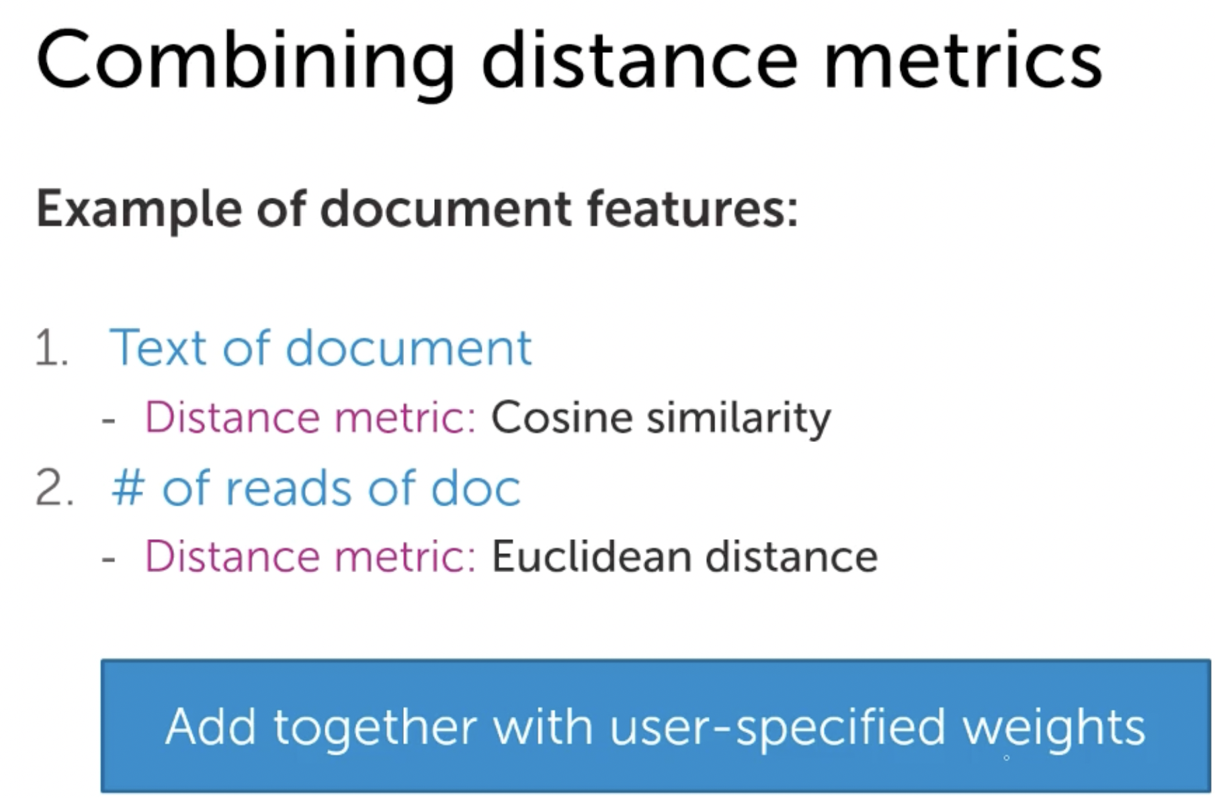

* Complexity of Brute force method: To find distances, N is the complexity and if we want to find K NN, complexity is N log(k) if we sort and then find Knn.
* **KD Tree**: Representation of data in the form of these bins which result in not finding distances for each query

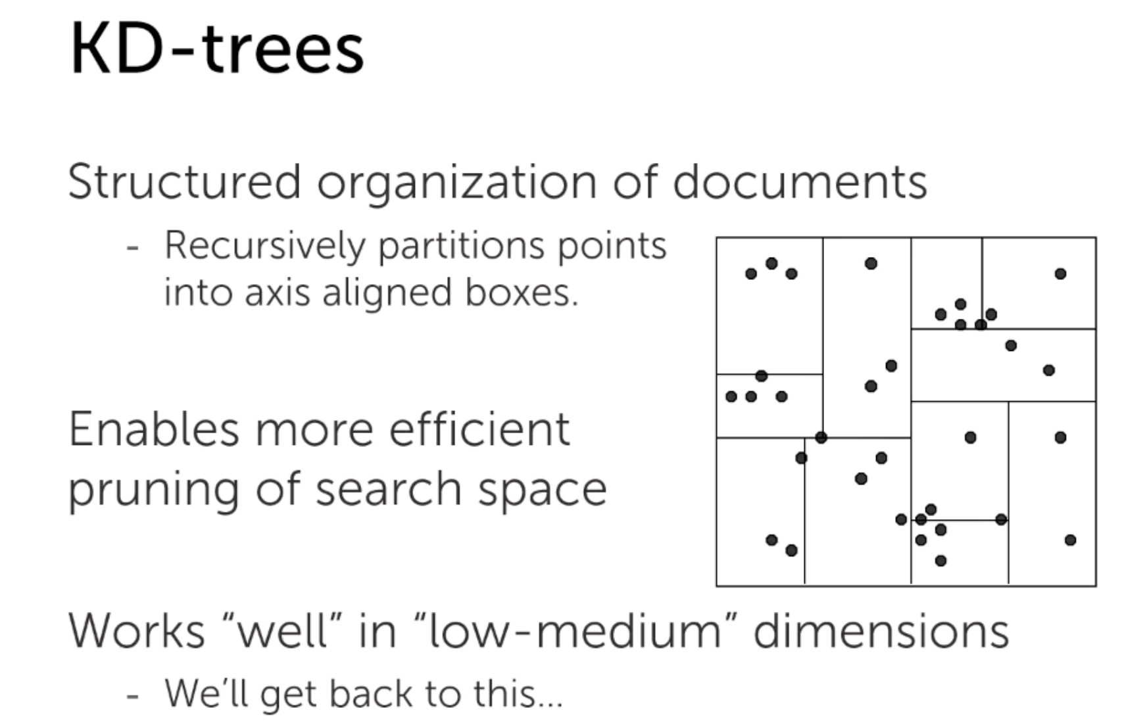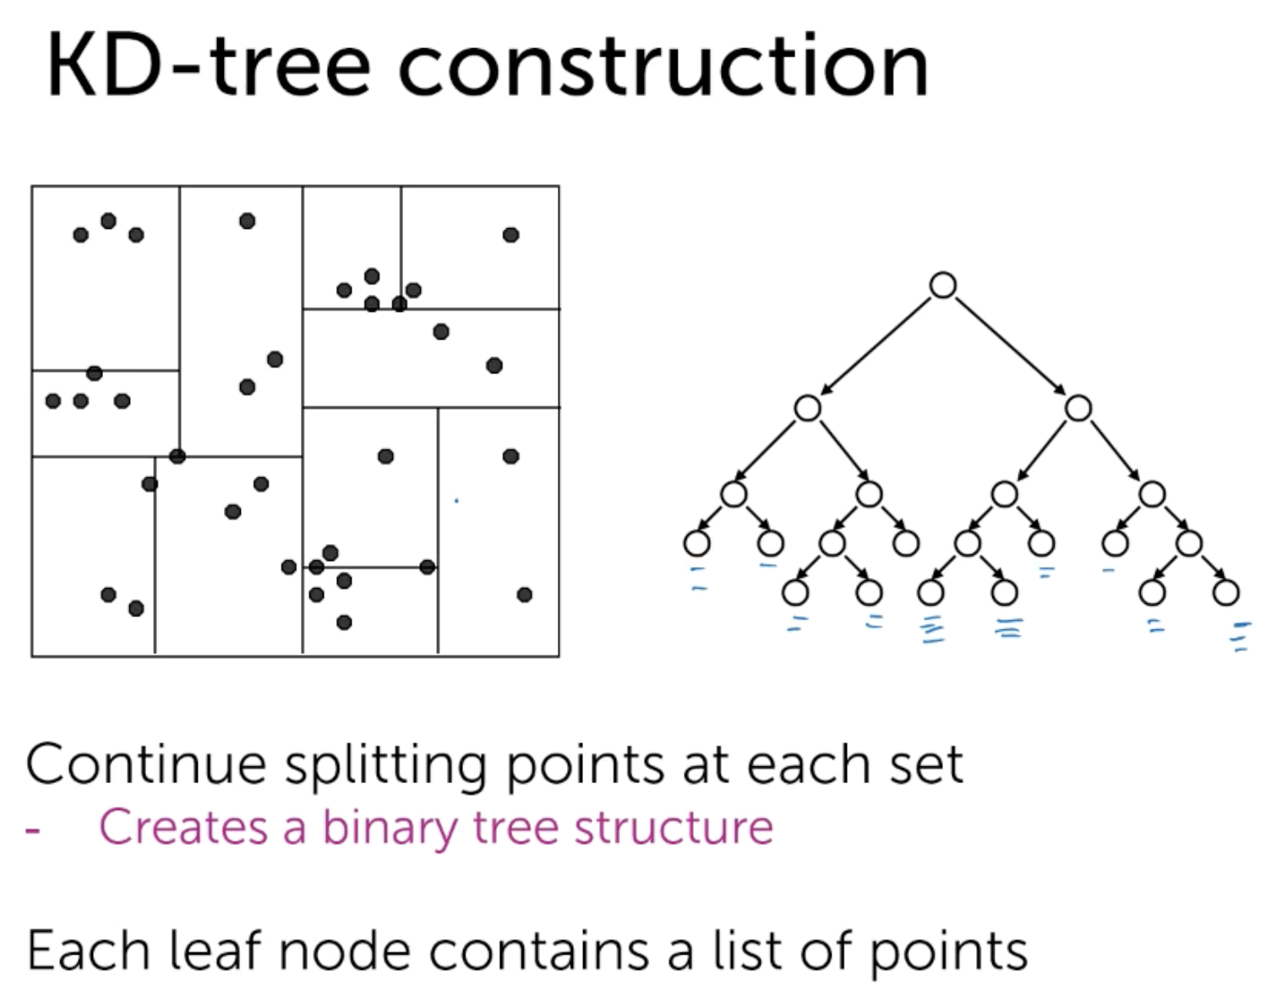

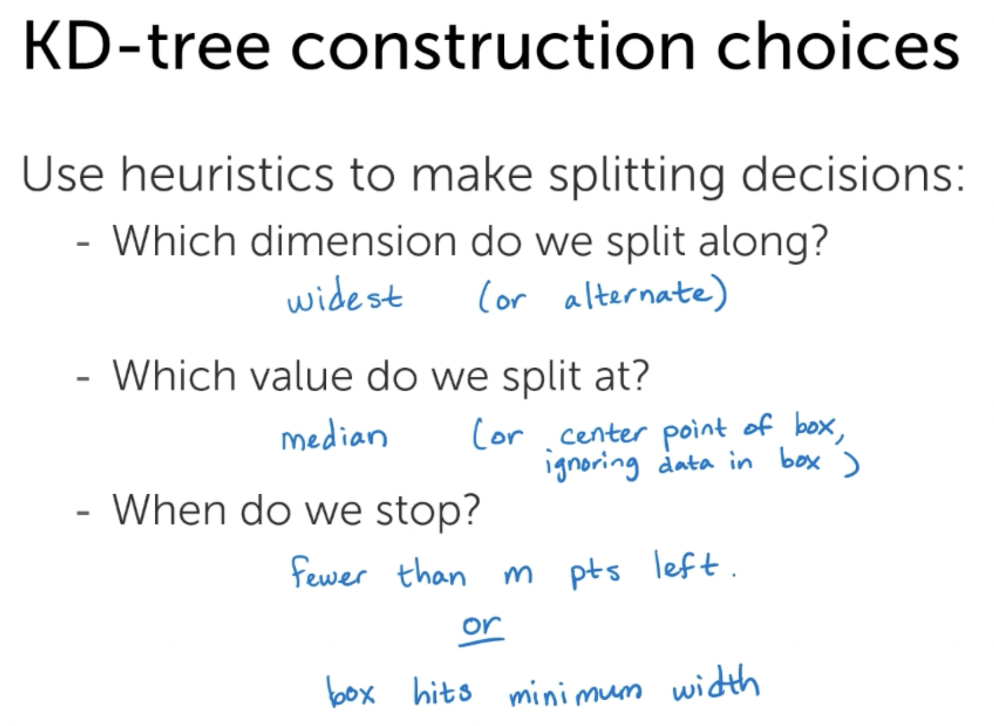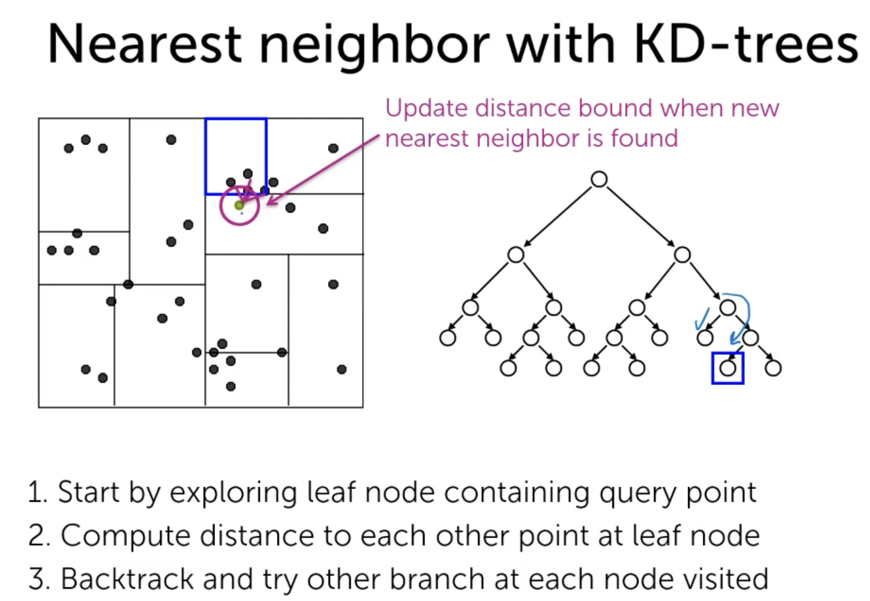

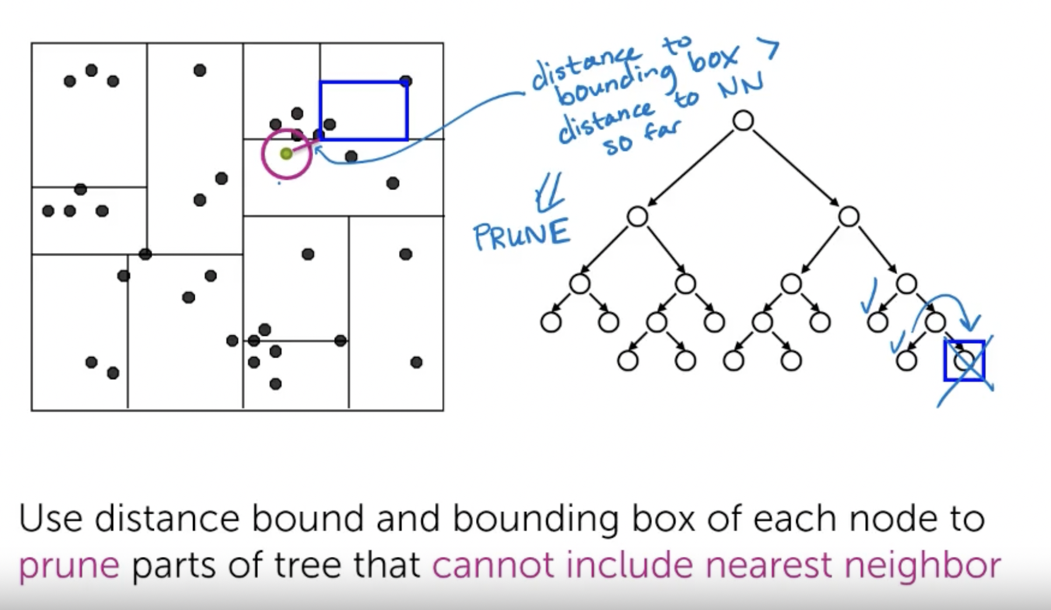

* Balanced Binary trees: Number of nodes on left and right side is equal. D is no of dimensions. Size is the total number of nodes in the tree. Here, we have considered 1 pt on each leaf. N is the number of leaves

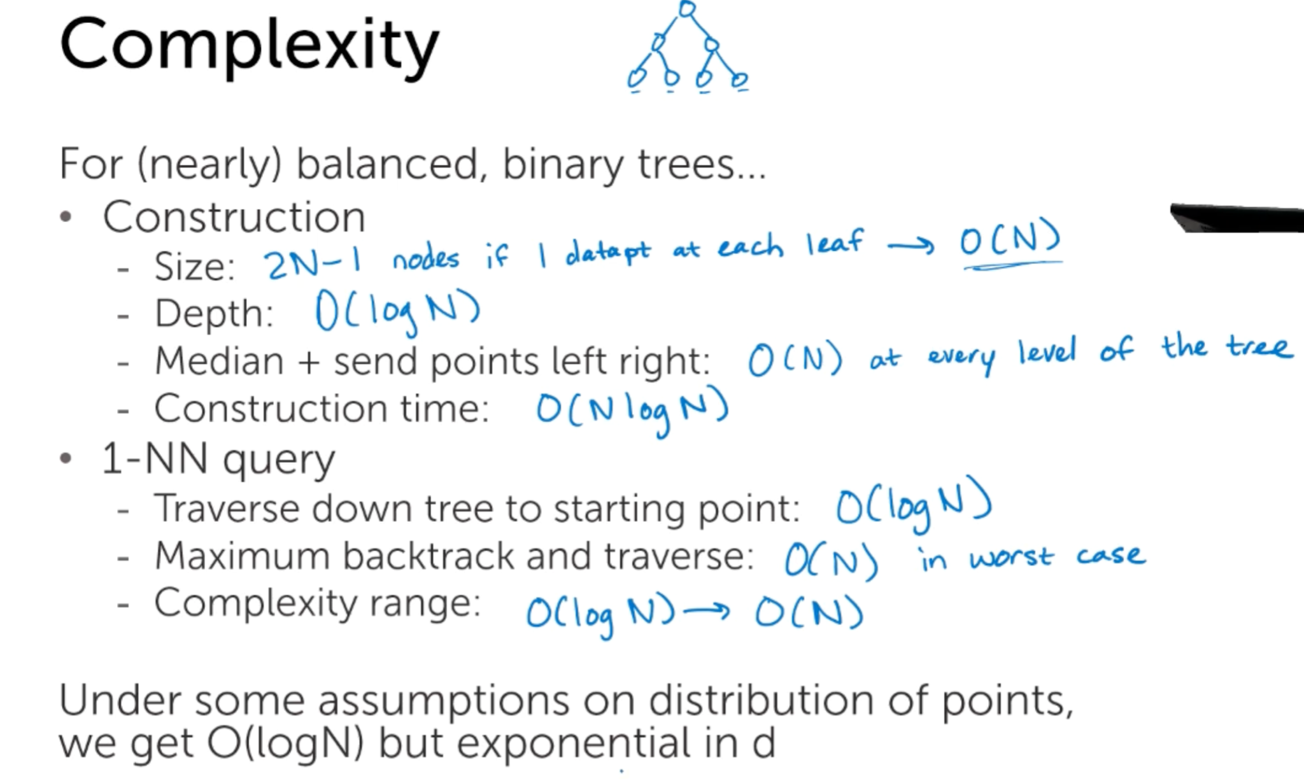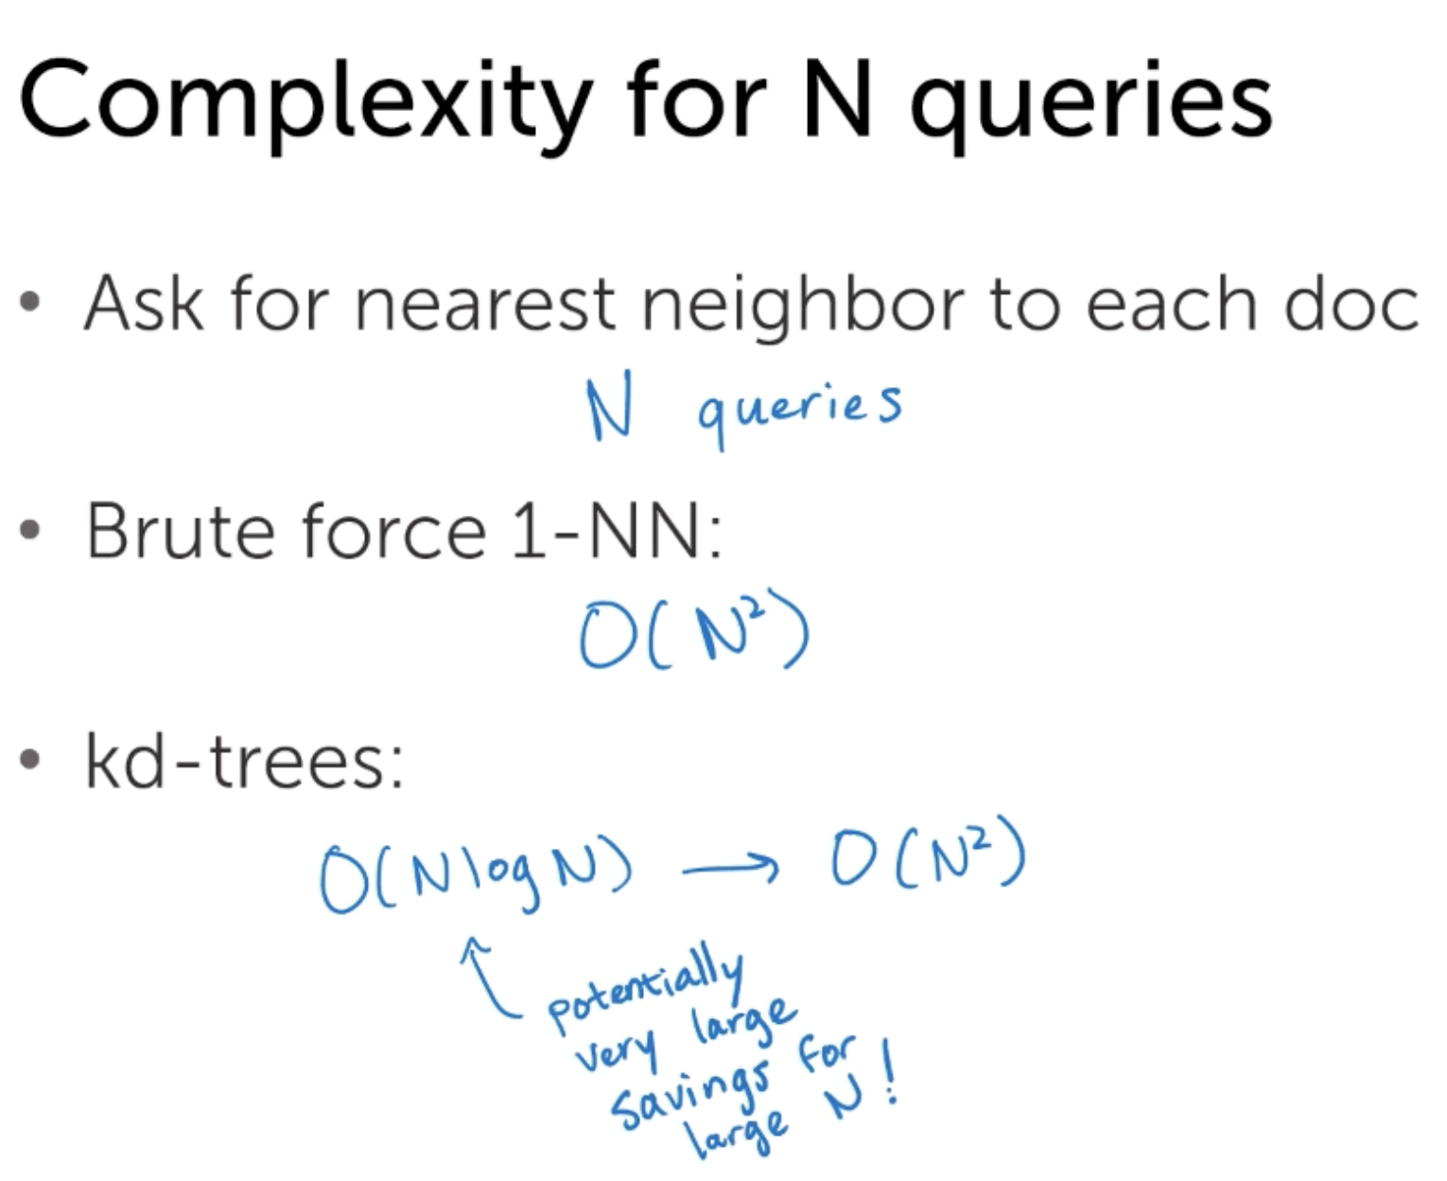

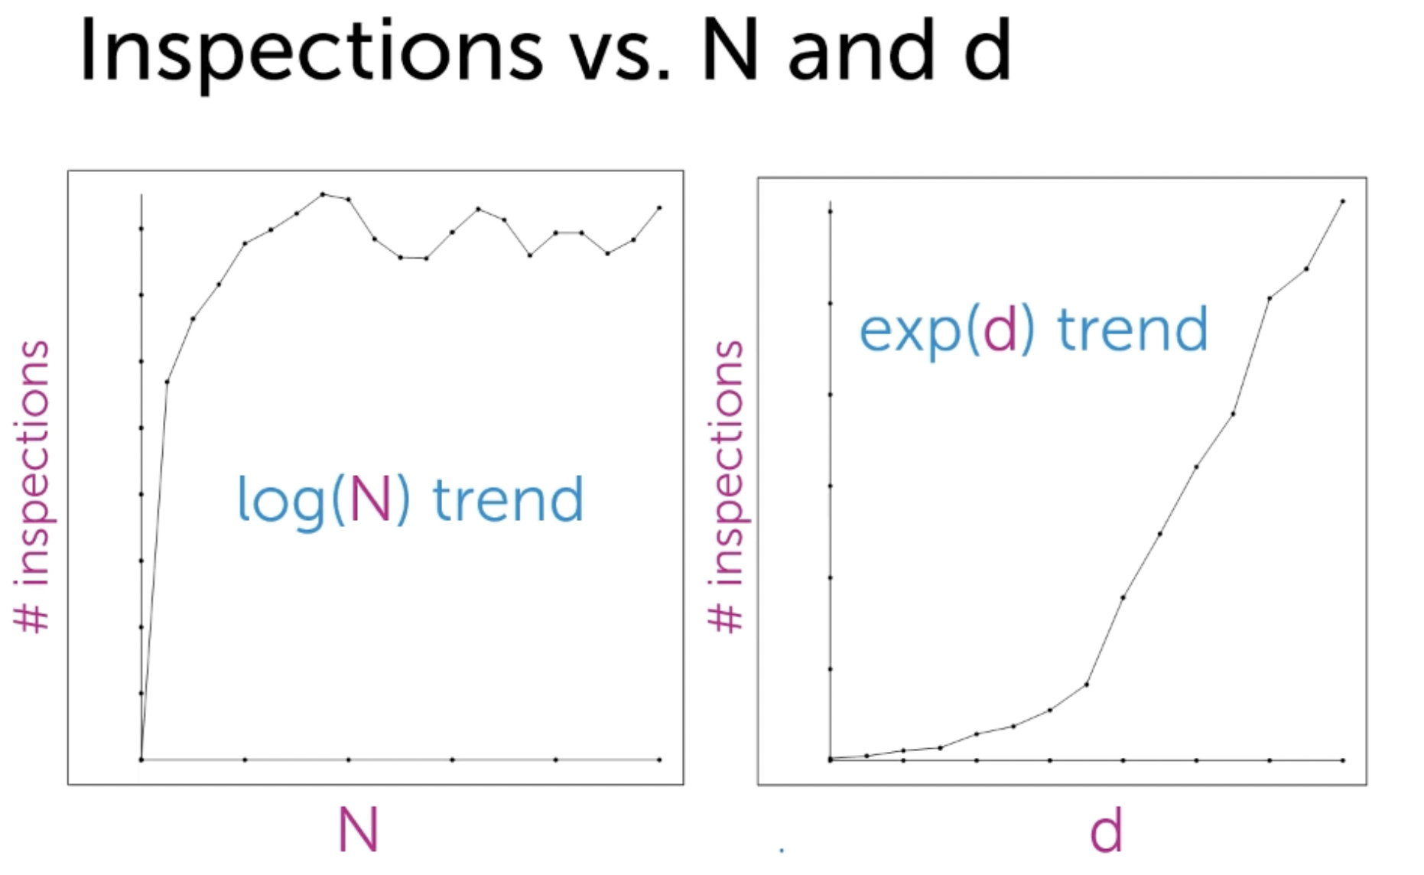

* As the dimension increases, the amount of inspection also increases. Thus, Kd trees aren’t useful in this way for a large number of dimensions.
* For KNN instead of 1nn with Kd trees, the process is the same only instead of nearest neighbor we search K nearest neighbor.

**Approximate KNN with Kd trees:**

* Instead of comparing the bounding box distance to the nearest neighbor distance we consider comparing bounding box distance to the fraction of nearest neighbor distance. This is because the bounding box distance might be less but the points in that bounding box might be far from the box boundary. Especially, when the data has a wide range but concentrated points in a particular region.

**Locality sensitive hashing:**

* Hash table:
*  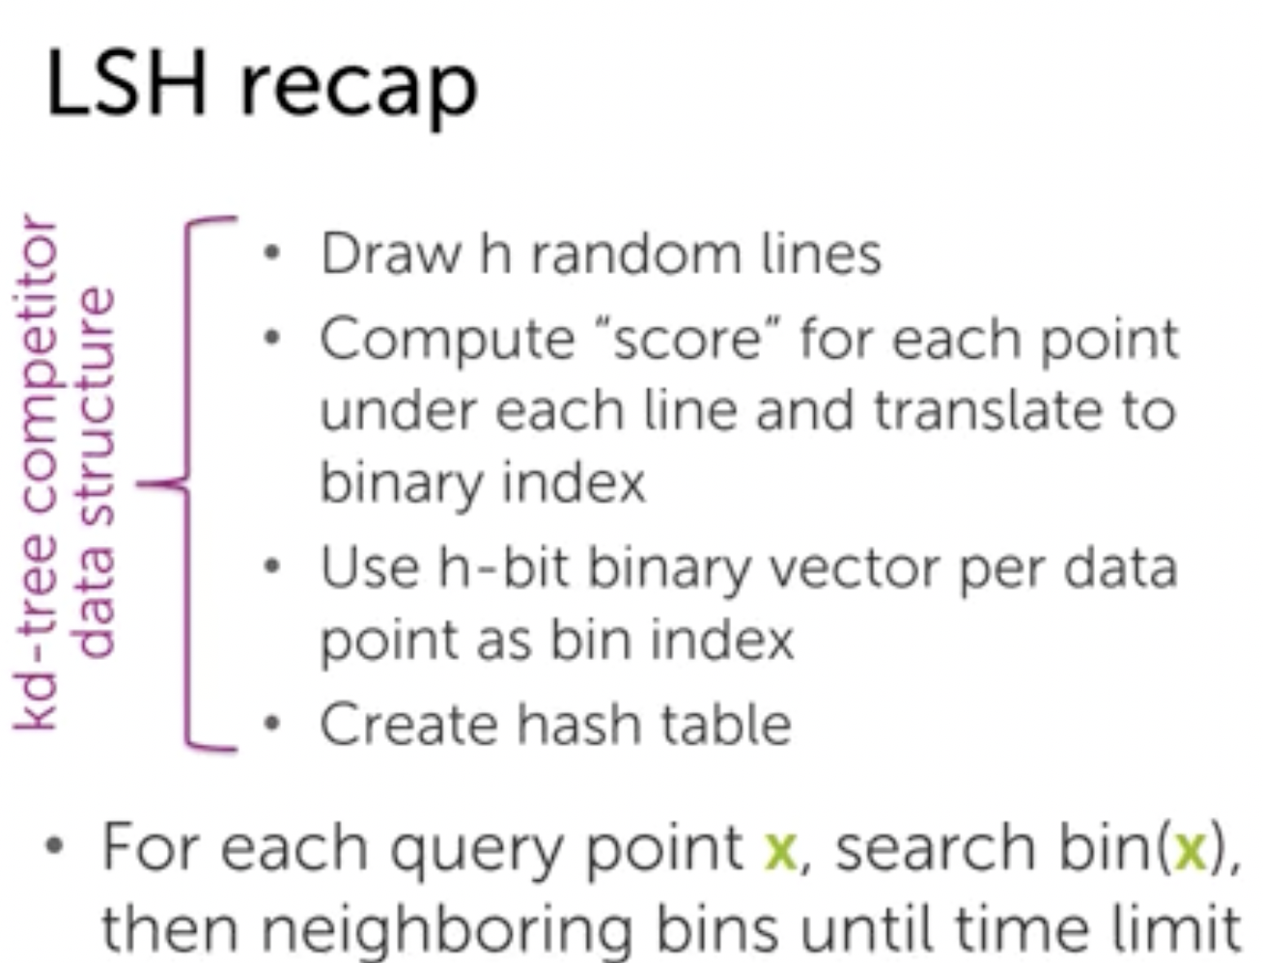
* We only search the nearest neighbour in the bin containing our point.
* Point with kd trees is that if there are many dimensions, traversing through each dimensions makes it similar to primitive knn

**WEEK III:**

* Introduction to clustering and unsupervised problems.
* Cluster is defined by the centre and shape
* **K means clustering :**
* Dividing space into the decision boundary is Voronoi Tessellation.

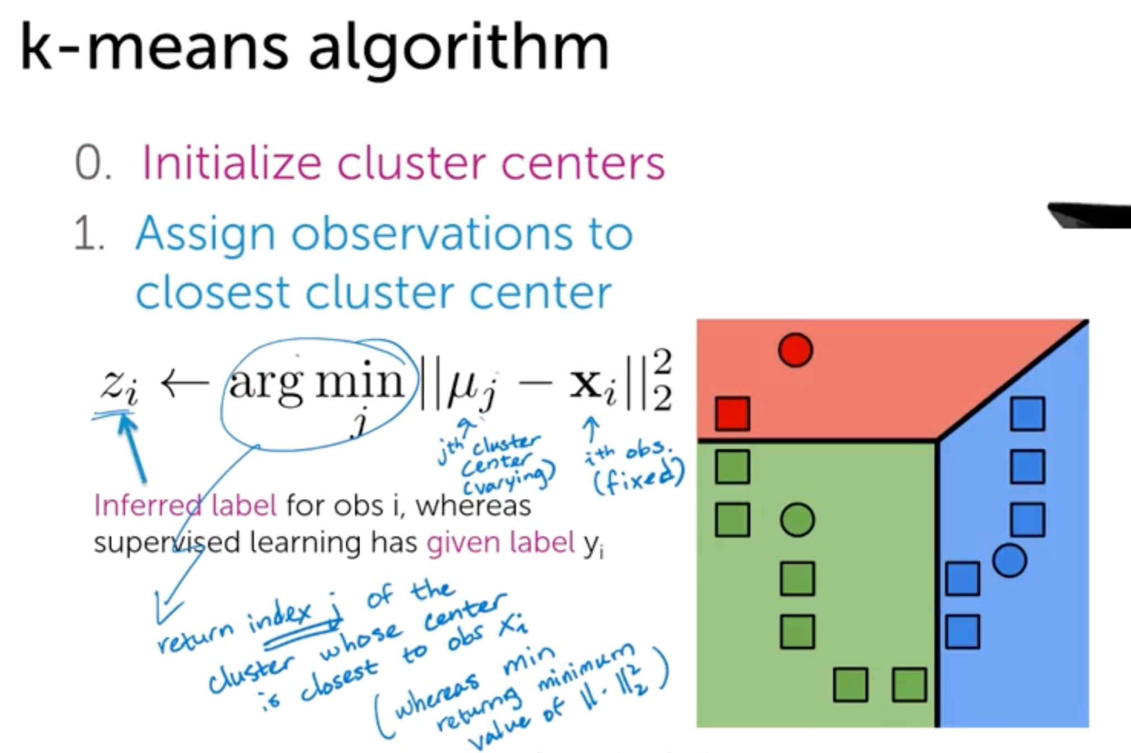 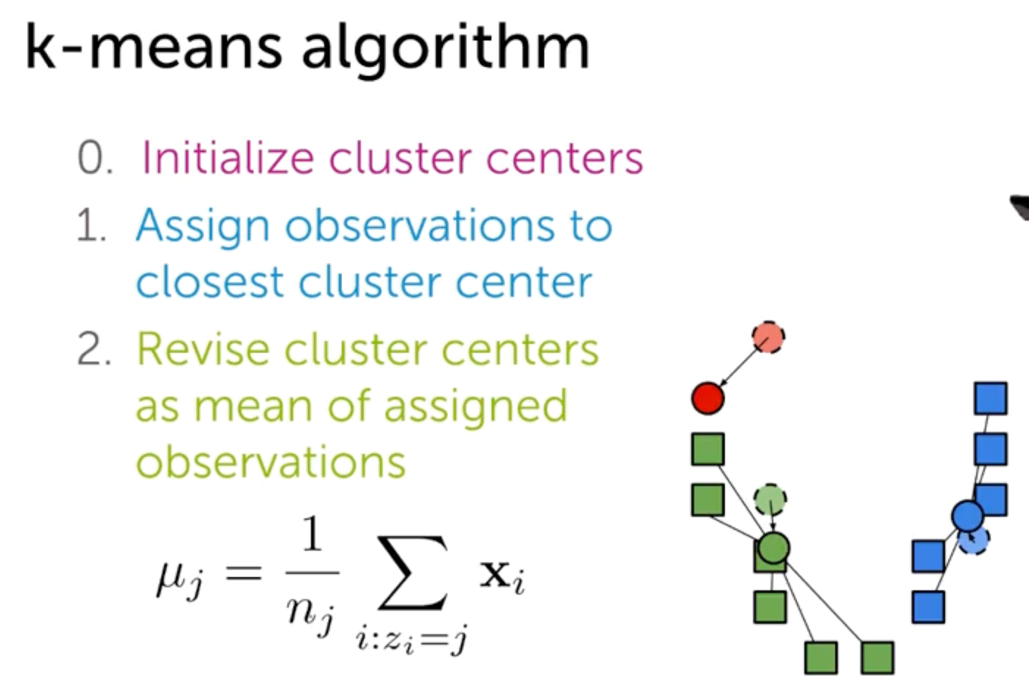

* Repeating steps till convergence,

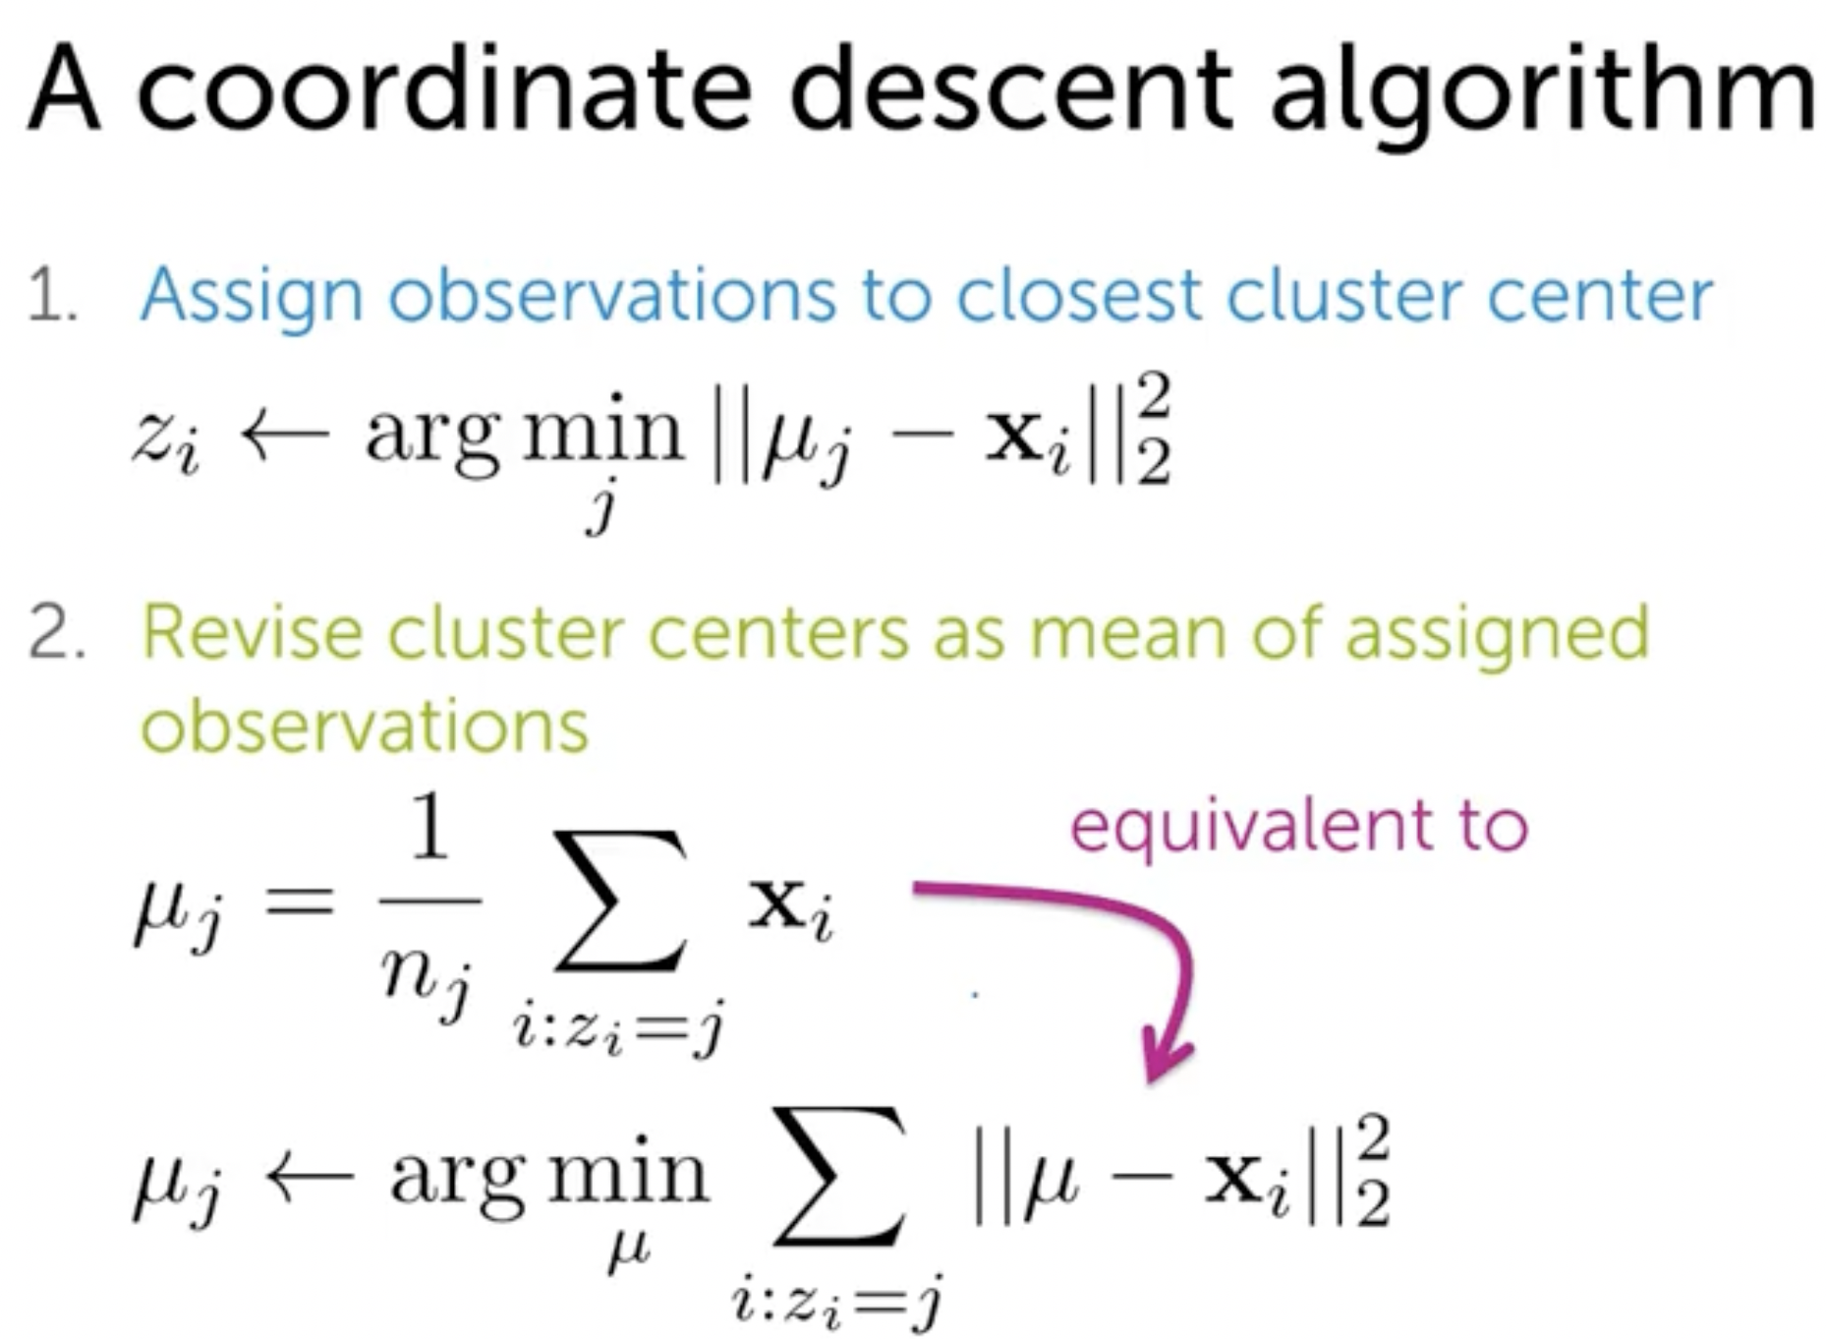 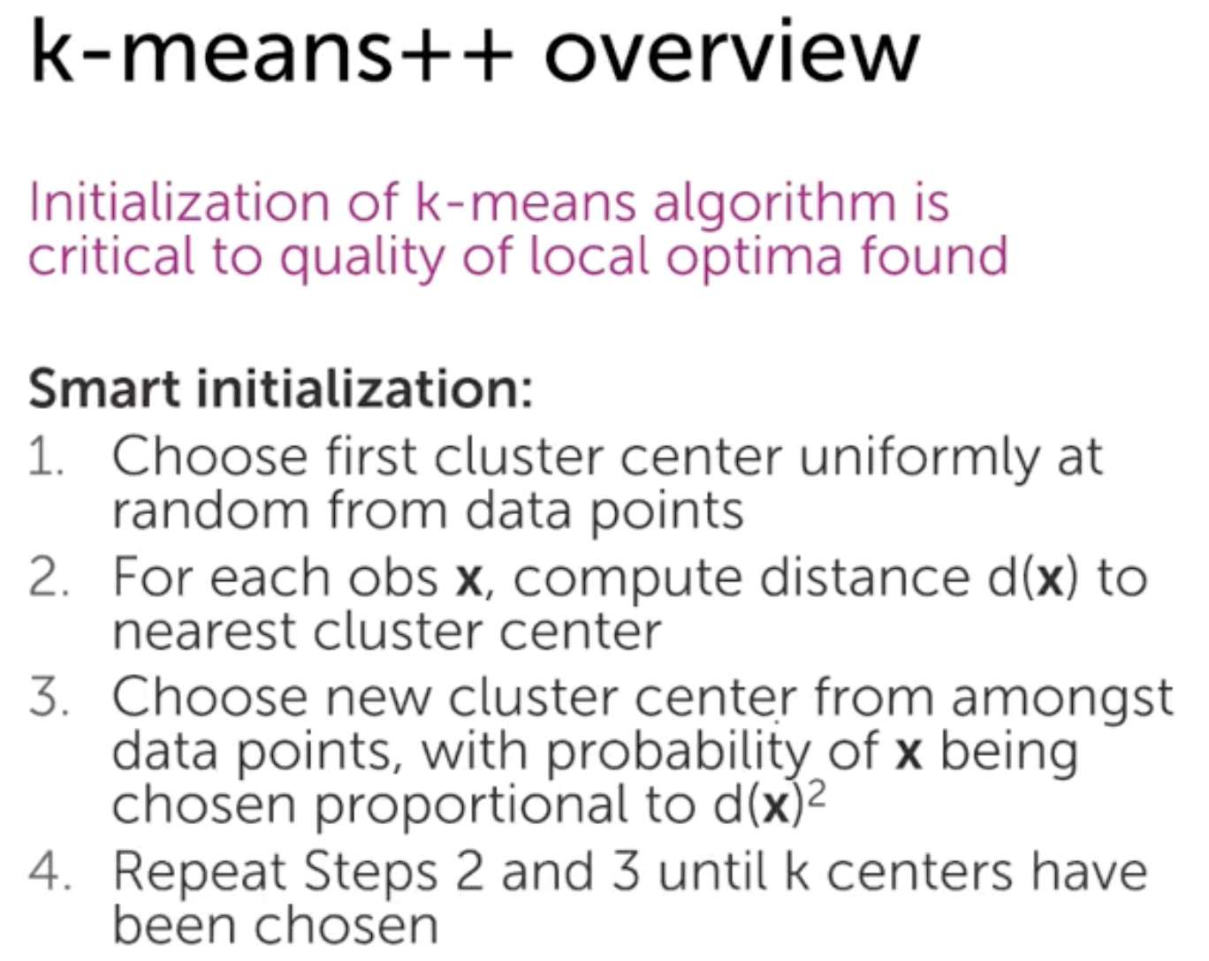

* K means is similar to coordinate descent. It converges to local minimum.
* K means it is very sensitive to initialisation.

K++ is costlier for initialisation, but converges faster.

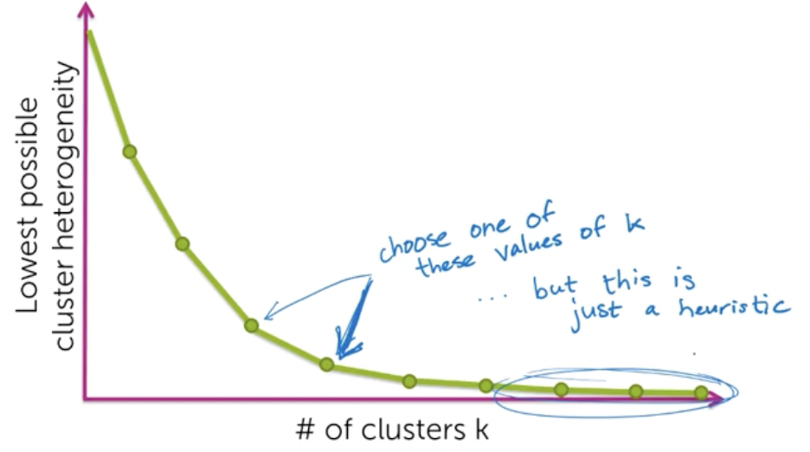

**Overfitting:**

This heterogeneity decreases as no of clusters increases. So we control the number of clusters by reiterating the algo with change in initialisation and trying to use different k and plotting these graphs.

Silhouette method.

**Data parallel task:**

Counting no of words in each document separately on diff machines for large no of documents.

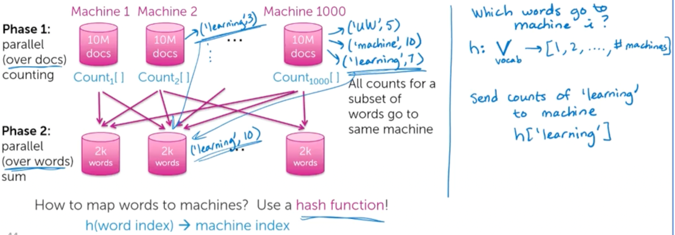

* 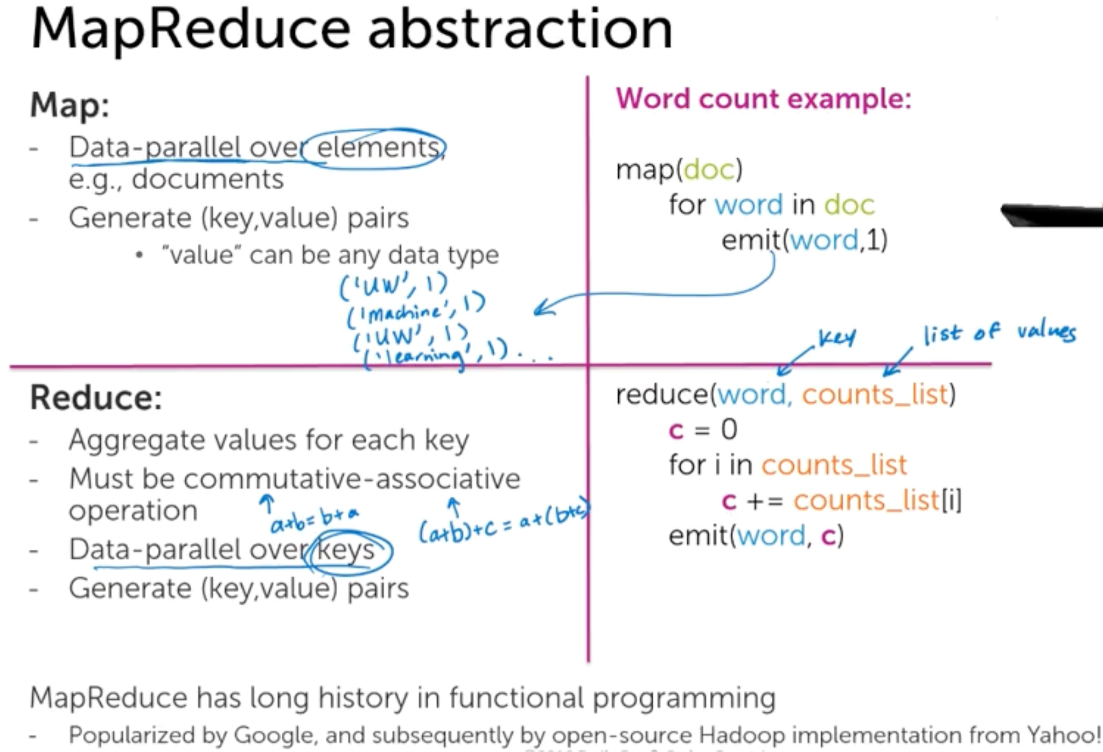
* 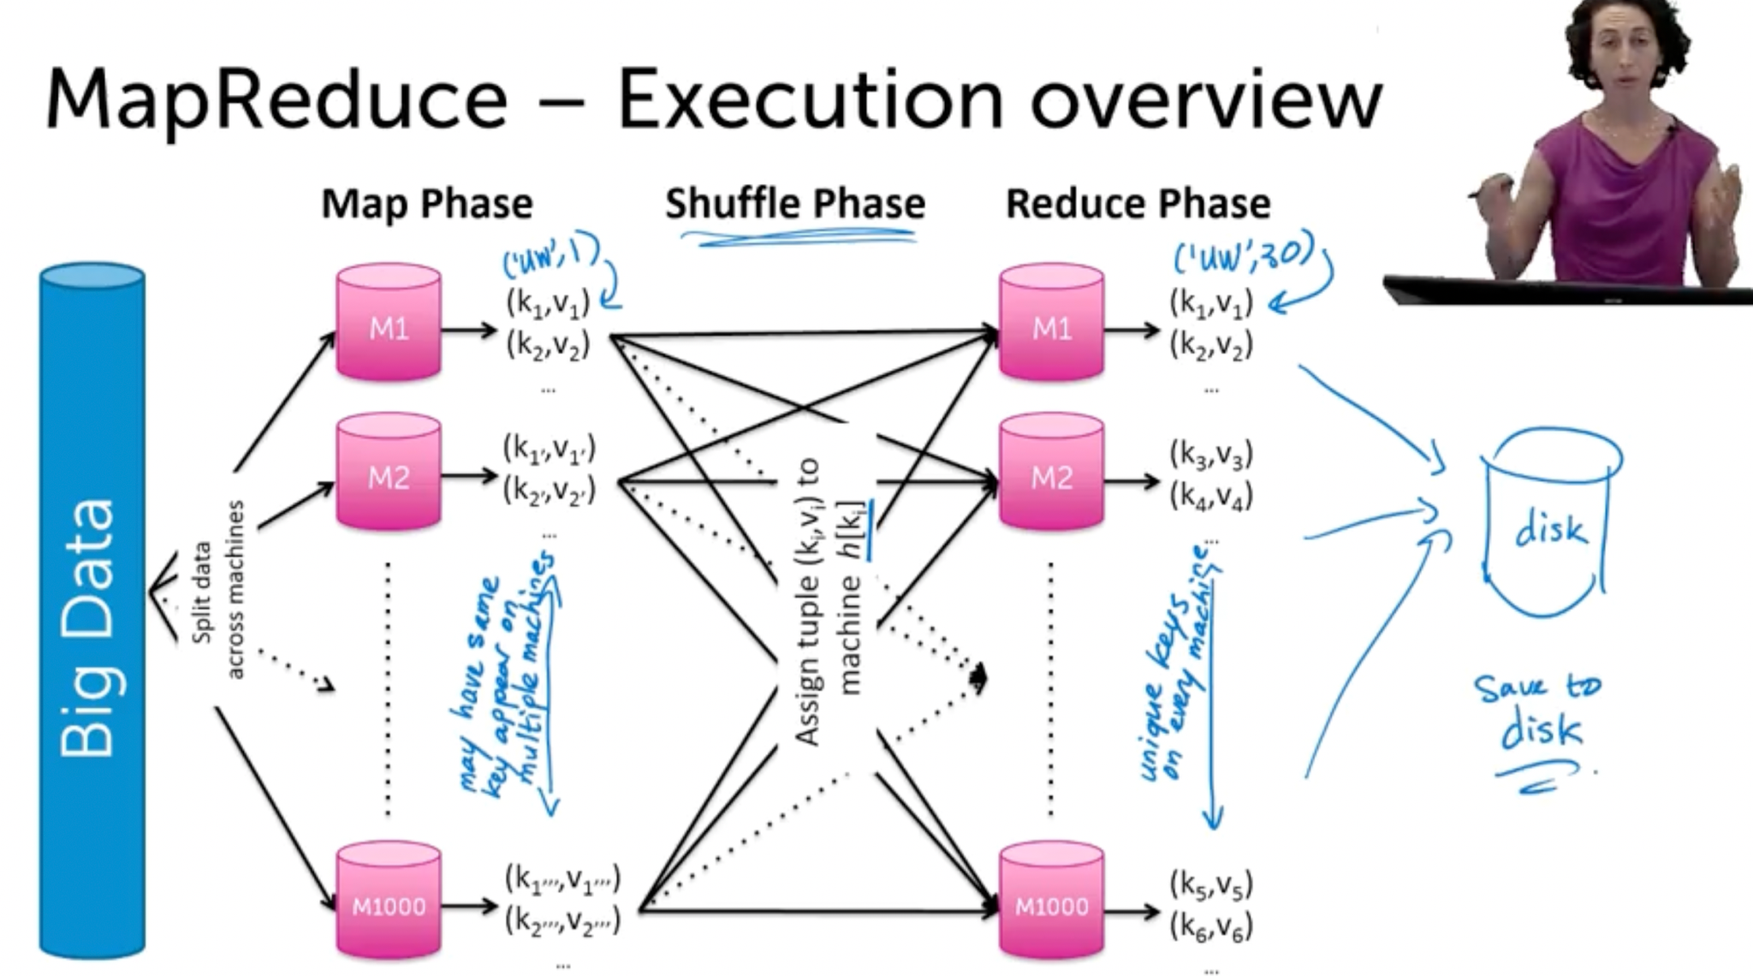
* Combiner performs the reduce step before shuffling. I.e it sums up the total number of words.